**FAST School of Computing**

**Object Oriented Programming – Spring 2025**

**Software Engineering Department**

**LAB 10**

**Operator Overloading in C++**

**Learning Outcomes**

In this lab you are expected to learn the following:

* Classes
* Constructors (Default, Parameterized)
* Initializer lists with constructors.
* Accessing objects using global functions
* Member Functions and Non-Member Functions
* Static and Constant Data Members and Member Functions
* Operator Overloading
* Friend Functions

**Note:** Plagiarism(from some else or internet) in any 1 question will lead to zero marks in the whole lab task.

**Problem 1 (Medium Level):**

**Overloading Arithmetic Operators for a Vector Class**

1. Create a class named Vector2D to represent a two-dimensional vector.
2. The class should have two private member variables: x and y (both floats) representing the vector's components.
3. Implement the following operator overloads as member functions:
   * +: To add two Vector2D objects (add corresponding components).
   * -: To subtract two Vector2D objects (subtract corresponding components).
   * *: To multiply a Vector2D object by a scalar (float).
4. Implement a display() method to print the x and y components of a Vector2D object.
5. Write a main() function to:
   * Create several Vector2D objects.
   * Demonstrate the use of the overloaded operators to perform vector addition, subtraction, and scalar multiplication.
   * Display the results using the display() method.

**Problem 2 (Medium Level ):**

**Overloading Relational and Stream Operators for a Student Class**

1. Create a class named Student with the following private member variables:
   * string name: To store the student's name.
   * float gpa: To store the student's GPA.
2. Implement the following operator overloads:
   * >: To compare two Student objects based on their GPA.
   * <: To compare two Student objects based on their GPA.
   * ==: To check if two Student objects have the same GPA.
   * <<: As a friend function, to output a Student object's information in a user-friendly format (e.g., "Name: Hifza, CGPA: 3.54").
   * >>: As a friend function, to read a Student object's information from the input stream.
3. Write a main() function to:
   * Create an array of Student objects.
   * Use the overloaded relational operators to compare students and find the student with the highest GPA.
   * Use the overloaded << and >> operators to take student data as input and display student information.

**Problem 3 (Hard Level):**

* Write a class **Matrix.**
* This class has **three private data members:**
* **rows: An integer that holds the numbers of rows for matrix**
* **columns: An integer that holds the numbers of columns for matrix**
* **matrix: An integer pointer to pointer that points to 2D array (rows x columns).**
* The class has the following member functions:

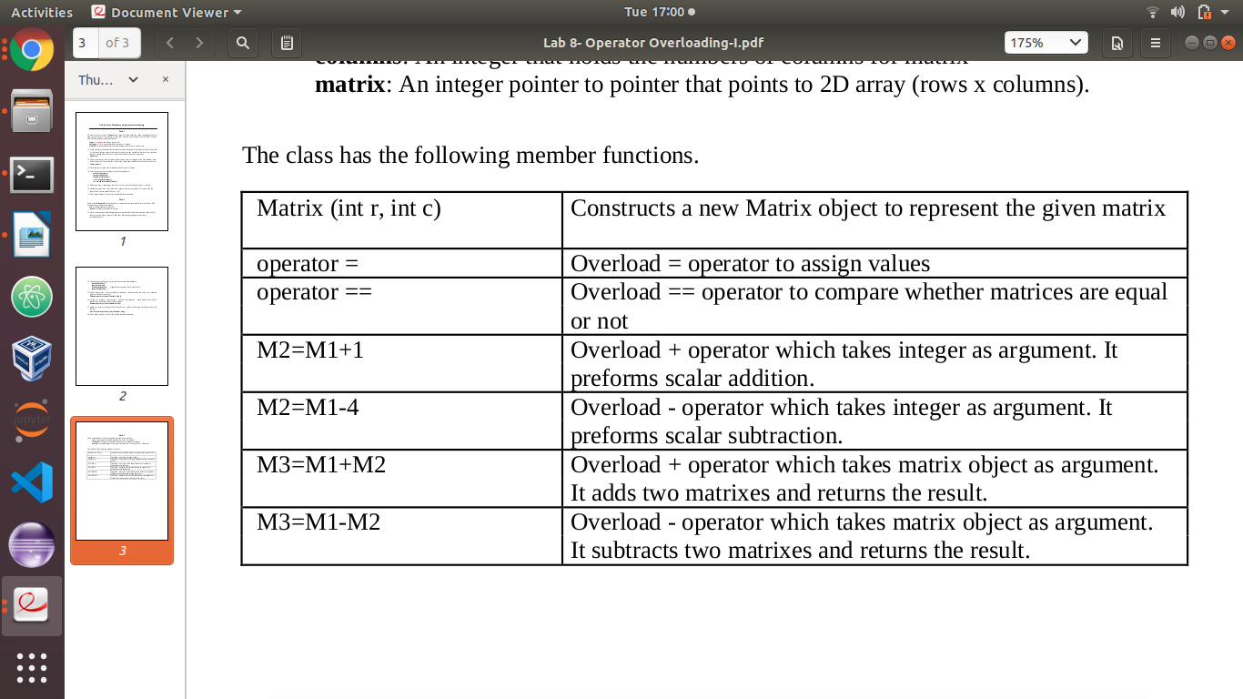

**Submission Details:**

1. Save each Task .cpp file with your roll no and lab number e.g. i22-XXXX_Lab10.cpp
2. Zip the .cpp file and screen shots (Do not create .rar file) with roll no and lab no. e.g. i22-XXXX_Lab10.zip.
3. Submit the zip file on google classroom.